UNITED STATES
SECURITIES AND EXCHANGE COMMISSION
Washington, D.C. 20549
___________________________________
FORM 8-K
___________________________________
CURRENT REPORT
Pursuant to Section 13 or 15(d)
of the Securities Exchange Act of 1934

Date of Report (date of earliest event reported): September 8, 2026
___________________________________
Quantinuum Inc.
(Exact name of registrant as specified in its charter)
___________________________________

Delaware  (State or other jurisdiction of  incorporation or organization) |  |  | 001-43328  (Commission File Number) |  |  | 41-4095842  (I.R.S. Employer Identification Number)
303 S Technology Court
Broomfield, CO 80021
(Address of principal executive offices and zip code)
(555) 888-7686
(Registrant's telephone number, including area code)
___________________________________
Check the appropriate box below if the Form 8-K filing is intended to simultaneously satisfy the filing obligation of the registrant under any of the following provisions:

☐ |  |  | Written communications pursuant to Rule 425 under the Securities Act (17 CFR 230.425)
☐ |  |  | Soliciting material pursuant to Rule 14a-12 under the Exchange Act (17 CFR 240.14a-12)
☐ |  |  | Pre-commencement communications pursuant to Rule 14d-2(b) under the Exchange Act (17 CFR 240.14d-2(b))
☐ |  |  | Pre-commencement communications pursuant to Rule 13e-4(c) under the Exchange Act (17 CFR 240.13e-4(c))
Securities registered pursuant to Section 12(b) of the Act:
Title of each class |  |  | Trading Symbol |  |  | Name of each exchange on which registered
Class A common stock, par value $0.0001 |  |  | QNT |  |  | Nasdaq Global Market
Indicate by check mark whether the registrant is an emerging growth company as defined in Rule 12b-2 of the Exchange Act.
Emerging growth company ☒
If an emerging growth company, indicate by check mark if the registrant has elected not to use the extended transition period for complying with any new or revised financial accounting standards provided pursuant to Section 13(a) of the Exchange Act. ☐

Item 1.01 - Entry into a Material Definitive Agreement

As previously announced by Quantinuum Inc. (together with its consolidated subsidiaries unless the context otherwise requires, the “Company”), in May 2026, the Company entered into a non-binding letter of intent (the “Letter of Intent”) with the U.S. Department of Commerce (the “Department of Commerce”) under the CHIPS Act of 2022, covering an award of up to an aggregate $100.0 million, to be disbursed to the Company in multiple payments, with $56.0 million to be made available on or about the date of award and two subsequent payments in connection with, and subject to, the Company’s achievement of certain project milestones. In exchange for receiving such award, under the terms of the Letter of Intent, the Company would be obligated to issue equity securities to the Department of Commerce in the full amount of the award, at an issuance price that is based on the lower of (i) the initial public offering price per share discounted by 20% and (ii) the publicly traded closing share price on the date of such award, discounted by 15%.

On September 4, 2026 (the “Award Date”), in furtherance of the Letter of Intent, (i) Quantinuum LLC, a subsidiary of the Company (the “Awardee”), entered into an Other Transaction Agreement (the “Award Agreement”) with the Department of Commerce, pursuant to which the Department of Commerce has agreed to award the Awardee up to an aggregate $100.0 million (the “Award”) on the terms and conditions set forth therein. In addition, on September 8, 2026, in connection with the Award Agreement, Quantinuum Inc., Quantinuum Holdings, LLC, a subsidiary of the Company, and the Awardee entered into a Securities Issuance Agreement (the “Securities Issuance Agreement”) with the Department of Commerce, pursuant to which the Department of Commerce received 2,369,528 shares of the Company’s Class A common stock (the “Shares”) from the Company.

Award Agreement

Under the Award Agreement, the Department of Commerce has agreed to award the Awardee up to an aggregate $100.0 million, to be disbursed to the Awardee in multiple payments, with $56.0 million made available on or about the Award Date and an additional $32.0 million and an additional $12.0 million made available, in each case, after the Awardee has achieved certain project milestones.

The Award contemplates that the Company will undertake certain activities at multiple existing U.S. project sites to address key technical challenges in scaling trapped-ion-based quantum computing systems. In particular, the project to which the Award relates (the “Project”) consists of research and development activities related to, among other things, (i) the development of low-loss integrated photonics at 422 nanometers, (ii) the prototyping of control application-specific integrated circuits (ASICs) on a high-voltage process for cryogenic operation and (iii) the development and packaging of reliable optical components at trapped-ion critical wavelengths. The Award may be used solely to pay eligible project costs (as set forth in the Award Agreement), which shall be consistent in all material respects with an approved budget plan.
The Award Agreement provides that the period of performance of the Award (the “Period of Performance”) terminates on the earlier of the completion of all project milestones and the fifth anniversary of the Award Date, unless earlier terminated in accordance with the Award Agreement. The Award Agreement provides that the Awardee may request an amendment of the Award Agreement to extend the Period of Performance, and the Department of Commerce shall not unreasonably withhold its consent to such amendment.

The Award Agreement includes certain data and intellectual property rights requirements with respect to the Awardee and grants certain data and intellectual property rights to the Department of Commerce. Among other things, (i) the Awardee is required to notify the Department of Commerce of any Subject Invention (as defined in the Award Agreement and which is generally any invention of intellectual property generated in the performance of Project activities funded under the Award Agreement that is or may be patentable and that is conceived or first actually reduced to practice by the Awardee in the performance of Project activities), (ii) the Awardee must maintain an intellectual property rights management plan for the Project throughout the Period of Performance that details the practice and protocols to be used to ensure domestic control of intellectual property funded by the Department of Commerce and describes the intended management and ownership of intellectual property, (iii) the U.S. government has a nonexclusive, nontransferable, irrevocable, royalty-free, fully paid-up, worldwide right and license to practice or have practiced on behalf of the United States any Subject Invention throughout the world for government purposes, (iv) the U.S. government has government purpose rights with respect to data generated under the Award Agreement, and (v) intellectual property generated in the performance of Project activities funded under the Award Agreement may not be sold, transferred, licensed or assigned to a foreign country of concern, a foreign entity of concern or any entity whose actions, policies or personnel decisions are controlled by any such country or entity, subject to limited exceptions, for the Period of Performance and at least ten years thereafter.

The Award Agreement also includes certain restrictions and provisions designed to require the Awardee to maintain a nexus with the United States. These restrictions include a requirement that the Awardee (or one of its controlled affiliates that is a domestic entity) maintain its rights to Project background intellectual property owned or licensed by it for so long as it is

necessary for the execution of the Project for the Period of Performance and at least ten years thereafter. Additionally, the Awardee must notify the Department of Commerce of any intent to sell, transfer, license or assign ownership of any intellectual property generated in the performance of Project activities funded under the Award Agreement, subject to limited exceptions, at least 60 days prior to any such transaction. Also, for the Period of Performance and for ten years thereafter, any Subject Invention must be predominantly produced or licensed for production in the United States, subject to certain limited exceptions.

Under the Award Agreement, the Department of Commerce has the right to claw back up to the full disbursed Award amount (in the form of debt payable to the Department of Commerce) in the event of (i) a material failure to comply with research security, domestic control of intellectual property or domestic production requirements set forth in the Award Agreement or (ii) a failure to timely complete certain required Project activities. The Department of Commerce may also terminate the Award Agreement in the event of a material failure to comply with research security, domestic control of intellectual property or domestic production requirements set forth in the Award Agreement or any provision determined by the Department of Commerce to be material. Furthermore, in the event the Awardee breaches any terms of the Award Agreement, the Department of Commerce may exercise certain remedies, including imposing additional award conditions designed to remedy the non-compliance, temporarily withholding or suspending payment, or removing the ability to withdraw funds. The Award Agreement contains certain cure rights for breaches that either (a) relate to meeting a milestone or required project activity date or (b) would not result in a material adverse effect on the Project or the Company’s business.

The Award Agreement contains representations, warranties and covenants applicable to the Company, including those relating to organization and good standing, corporate power, authorization, no conflict, enforceability, accuracy of financial statements, off-balance sheet liabilities, litigation and tax return filings. The Awardee has agreed to indemnify the Department of Commerce from and against losses for which it may become responsible because of a claim asserted by a third party related to the Award Agreement or the Project, other than those claims based solely on the conduct of the Department of Commerce or that arise from the Department of Commerce’s bad faith, gross negligence or willful misconduct. In no event will Awardee’s total liability arising out of such indemnification obligations exceed the total amount of the Award.

The foregoing description of the Award Agreement is not complete and is qualified in its entirety by reference to the copy of the Award Agreement that the Company intends to file as an exhibit to its Quarterly Report on Form 10-Q for the quarterly period ending September 30, 2026.

Securities Issuance Agreement

Pursuant to the Securities Issuance Agreement, the Company has granted the Department of Commerce certain registration rights. In particular, the Company has agreed to use commercially reasonable efforts to file a shelf registration statement covering the resale of the Shares (the “Shelf Registration Statement”) by the date that is three months after the date of such agreement, cause such the Shelf Registration Statement to be declared effective under the Securities Act of 1933, as amended (the “Securities Act”), as soon as practicable after the filing thereof and keep the Shelf Registration Statement continuously effective and usable for resale of such the Registrable Securities (as defined in the Securities Issuance Agreement) until such time as there are no Registrable Securities remaining. If the Department of Commerce or any other Holders (as defined in the Securities Issuance Agreement) intend to distribute any Registrable Securities by means of an underwritten offering, the Company has agreed to take all reasonable steps to facilitate such distribution; provided, that the Company shall not be required to facilitate more than one completed underwritten offering within any 12-month period and the Company shall not be required to facilitate an underwritten offering unless the total number of shares of the Company’s Class A common stock expected to be sold in such offering exceeds at least 20% of the total number of Shares issued under the Securities Issuance Agreement. In the event an effective Shelf Registration Statement is not available and the Company intends to register equity securities for sale to the public, the Company will be required to give notice of such registration to the Department of Commerce and the other Holders, and, subject to certain limitations, include their Registrable Securities in such registration statement and, if applicable, underwritten offering. The Company has agreed to pay certain expenses relating to such registrations and indemnify the Department of Commerce and the other Holders against (or make contributions in respect of) certain liabilities that may arise relating to such registrations.

The Securities Issuance Agreement also provides that if, the Department of Commerce terminates the Award Agreement for convenience at any time prior to the end of the Award Period (as defined therein), the Company may repurchase from the Department of Commerce, at an aggregate purchase price of $1.00, that number of Shares held by the Department of Commerce equal to the total number of Shares issued under the Securities Issuance Agreement, multiplied by a percentage equal to (i) the total amount of Award funds that the Awardee has not received or has returned prior to being applied to eligible project costs, divided by (ii) $100.0 million (the maximum amount of the Award).

Pursuant to the Securities Issuance Agreement, the Department of Commerce has agreed to transfer restrictions on Shares that may be repurchased by the Company if the Department of Commerce terminates the Award Agreement for convenience prior

to the Awardee’s receipt of the full Award. The Department of Commerce may transfer only a number of shares equal to the total number of Shares issued under the Securities Issuance Agreement, multiplied by a percentage equal to (i) the aggregate amount of Award funds that the Awardee has withdrawn and not returned divided by (ii) $100.0 million (the maximum amount of the Award). The Department of Commerce has also agreed that it will not transfer any Shares in a privately negotiated transaction to any of the Company’s competitors or any transferee whose ownership of the Shares would (or could reasonably be expected to) cause the Company or the Awardee to violate any provision under the Award Agreement. The Department of Commerce has also agreed that it will not vote any Shares, except on certain matters that would have the effect of changing the authorized number of shares of the Company’s Class A common stock, changing the par value of a share of the Company’s Class A common stock or changing the powers, preferences or special rights of the shares of the Company’s Class A common stock so as to affect them adversely.

The Securities Issuance Agreement contains representations, warranties and covenants applicable to the Company, including those relating to organization and good standing, corporate power, authorization, no conflict, enforceability, accuracy of reports filed with the Securities and Exchange Commission and financial statements, and disclosure controls litigation.

The foregoing description of the Securities Issuance Agreement is not complete and is qualified in its entirety by reference to the copy of the Securities Issuance Agreement that the Company intends to file as an exhibit to its Quarterly Report on Form 10-Q for the quarterly period ending September 30, 2026.
Item 3.02 - Results of Operations and Financial Condition

The information under Item 1.01 of this Current Report on Form 8-K is incorporated herein by reference. The issuance of the Shares by the Company was made in reliance upon the exemption from the registration requirements of the Securities Act set forth in Section 4(a)(2) thereof as a transaction by an issuer not involving any public offering, and the transfer of the Shares by the Awardee to the Department of Commerce was made pursuant to an exemption from the registration requirements of the Securities Act that is commonly referred to as the Section 4(a)(11/2) exemption.

Item 7.01 - Regulation FD Disclosure

On September 8, 2026, the Company issued a press release announcing the Company’s entry into the Award Agreement. The press release is furnished as Exhibit 99.1 to this Current Report on Form 8-K.

The information furnished pursuant to this Item 7.01, including the accompanying Exhibit 99.1, shall not be deemed “filed” for purposes of Section 18 of the Securities Exchange Act of 1934, as amended (the “Exchange Act”), or otherwise subject to the liabilities of such Section and shall not be deemed to be incorporated by reference into any filing made by the Company under the Securities Act or the Exchange Act.

Item 9.01 - Financial Statements and Exhibits
(d) Exhibits:

Exhibit No. |  |  |  |  |  | Description
99.1 |  |  |  |  |  | Press release of Quantinuum Inc. dated September 8, 2026, relating to the Award Agreement.
104 |  |  |  |  |  | Cover Page Interactive Data File (embedded within the Inline XBRL document)

SIGNATURE

Pursuant to the requirements of the Securities Exchange Act of 1934, the registrant has duly caused this report to be signed on its behalf by the undersigned hereunto duly authorized.

Dated: 9/8/2026
QUANTINUUM INC.
By: |  |  | /s/ Nitesh Sharan
Name: |  |  | Nitesh Sharan
Title: |  |  | Chief Financial Officer
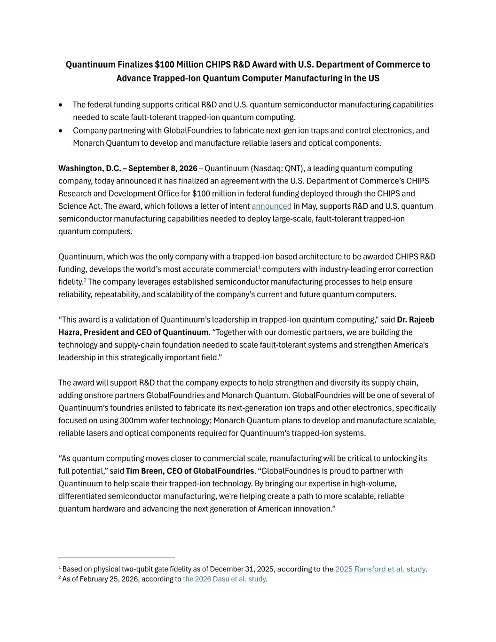

Quantinuum Finalizes $100 Million CHIPS R&D Award with U.S. Department of Commerce to Advance Trapped-Ion Quantum Computer Manufacturing in the US • The federal funding supports critical R&D and U.S. quantum semiconductor manufacturing capabilities needed to scale fault-tolerant trapped-ion quantum computing. • Company partnering with GlobalFoundries to fabricate next-gen ion traps and control electronics, and Monarch Quantum to develop and manufacture reliable lasers and optical components. Washington, D.C. – September 8, 2026 – Quantinuum (Nasdaq: QNT), a leading quantum computing company, today announced it has finalized an agreement with the U.S. Department of Commerce’s CHIPS Research and Development Office for $100 million in federal funding deployed through the CHIPS and Science Act. The award, which follows a letter of intent announced in May, supports R&D and U.S. quantum semiconductor manufacturing capabilities needed to deploy large-scale, fault-tolerant trapped-ion quantum computers. Quantinuum, which was the only company with a trapped-ion based architecture to be awarded CHIPS R&D funding, develops the world’s most accurate commercial1 computers with industry-leading error correction fidelity.2 The company leverages established semiconductor manufacturing processes to help ensure reliability, repeatability, and scalability of the company’s current and future quantum computers. “This award is a validation of Quantinuum’s leadership in trapped-ion quantum computing," said Dr. Rajeeb Hazra, President and CEO of Quantinuum. “Together with our domestic partners, we are building the technology and supply-chain foundation needed to scale fault-tolerant systems and strengthen America's leadership in this strategically important field.” The award will support R&D that the company expects to help strengthen and diversify its supply chain, adding onshore partners GlobalFoundries and Monarch Quantum. GlobalFoundries will be one of several of Quantinuum’s foundries enlisted to fabricate its next-generation ion traps and other electronics, specifically focused on using 300mm wafer technology; Monarch Quantum plans to develop and manufacture scalable, reliable lasers and optical components required for Quantinuum’s trapped-ion systems. “As quantum computing moves closer to commercial scale, manufacturing will be critical to unlocking its full potential,” said Tim Breen, CEO of GlobalFoundries. “GlobalFoundries is proud to partner with Quantinuum to help scale their trapped-ion technology. By bringing our expertise in high-volume, differentiated semiconductor manufacturing, we're helping create a path to more scalable, reliable quantum hardware and advancing the next generation of American innovation.” 1 Based on physical two-qubit gate fidelity as of December 31, 2025, according to the 2025 Ransford et al. study. 2 As of February 25, 2026, according to the 2026 Dasu et al. study.

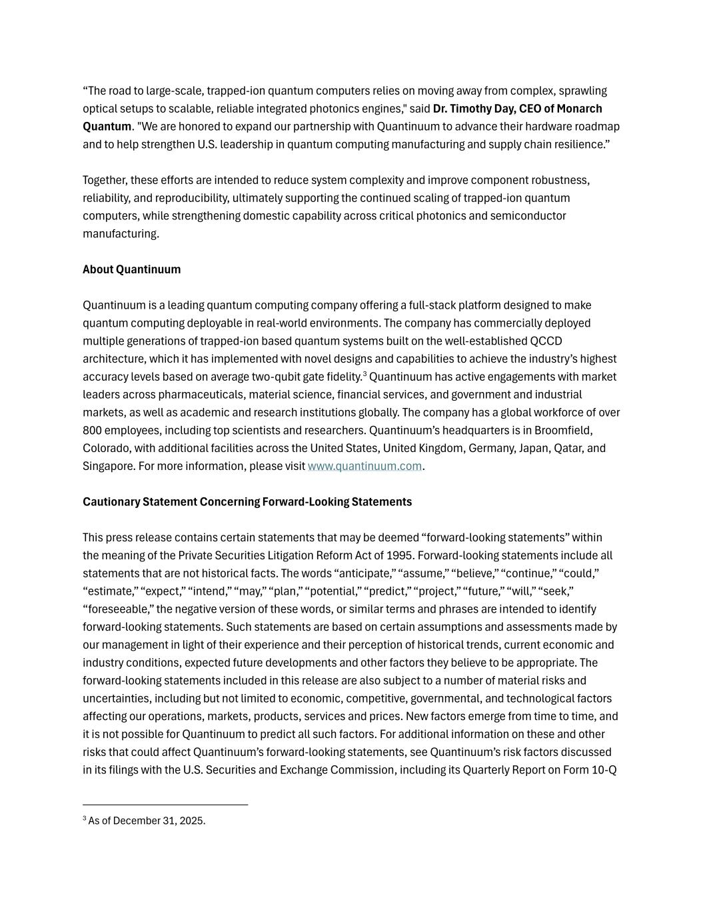
“The road to large-scale, trapped-ion quantum computers relies on moving away from complex, sprawling optical setups to scalable, reliable integrated photonics engines," said Dr. Timothy Day, CEO of Monarch Quantum. "We are honored to expand our partnership with Quantinuum to advance their hardware roadmap and to help strengthen U.S. leadership in quantum computing manufacturing and supply chain resilience.” Together, these efforts are intended to reduce system complexity and improve component robustness, reliability, and reproducibility, ultimately supporting the continued scaling of trapped-ion quantum computers, while strengthening domestic capability across critical photonics and semiconductor manufacturing. About Quantinuum Quantinuum is a leading quantum computing company offering a full-stack platform designed to make quantum computing deployable in real-world environments. The company has commercially deployed multiple generations of trapped-ion based quantum systems built on the well-established QCCD architecture, which it has implemented with novel designs and capabilities to achieve the industry’s highest accuracy levels based on average two-qubit gate fidelity.3 Quantinuum has active engagements with market leaders across pharmaceuticals, material science, financial services, and government and industrial markets, as well as academic and research institutions globally. The company has a global workforce of over 800 employees, including top scientists and researchers. Quantinuum’s headquarters is in Broomfield, Colorado, with additional facilities across the United States, United Kingdom, Germany, Japan, Qatar, and Singapore. For more information, please visit www.quantinuum.com. Cautionary Statement Concerning Forward-Looking Statements This press release contains certain statements that may be deemed “forward-looking statements” within the meaning of the Private Securities Litigation Reform Act of 1995. Forward-looking statements include all statements that are not historical facts. The words “anticipate,” “assume,” “believe,” “continue,” “could,” “estimate,” “expect,” “intend,” “may,” “plan,” “potential,” “predict,” “project,” “future,” “will,” “seek,” “foreseeable,” the negative version of these words, or similar terms and phrases are intended to identify forward-looking statements. Such statements are based on certain assumptions and assessments made by our management in light of their experience and their perception of historical trends, current economic and industry conditions, expected future developments and other factors they believe to be appropriate. The forward-looking statements included in this release are also subject to a number of material risks and uncertainties, including but not limited to economic, competitive, governmental, and technological factors affecting our operations, markets, products, services and prices. New factors emerge from time to time, and it is not possible for Quantinuum to predict all such factors. For additional information on these and other risks that could affect Quantinuum’s forward-looking statements, see Quantinuum’s risk factors discussed in its filings with the U.S. Securities and Exchange Commission, including its Quarterly Report on Form 10-Q 3 As of December 31, 2025.


for the period ended June 30, 2026, as such risk factors may be updated from time to time. Any forward- looking statement speaks only as of the date on which it is made, and, except as required by law, Quantinuum does not undertake any obligation to update or revise any forward-looking statement, whether as a result of new information, future events or otherwise.

